Kontrakt - Speciale

- Den studerende
Navn:  Lasse Simmelsgaard Børresen |  | CPR-nr.:  0501911607 | Tlf. nr.:  004541356060
Uddannelse:  Civilingeniør / kandidat i Robotteknologi |  |  | Student e-mail:  laboe@student.sdu.dk
- Oplysninger om specialet
Specialets danske titel:
Pepper, the Moody Mood Lamp: A Colour
Changing and Morphing Lamp for Exploring
Human Robot Interaction, Artificial Life and
Intuitive Reaction to Domestic Sound Events Through Machine Learning
Specialets engelske titel:
Pepper, the Moody Mood Lamp: A Colour
Changing and Morphing Lamp for Exploring
Human Robot Interaction, Artificial Life and
Intuitive Reaction to Domestic Sound Events
Through Machine Learning
ECTS-omfang:
30 ECTS-point
40 ECTS-point
45 ECTS-point (kun studerende optaget på en 4+4 PhD-uddannelse)
Startdato:*  1. september 2014  2. januar 2015  andet, hvad?  En anden startdato end de fastlagte, dvs. d. 1. september eller d. 1. februar skal begrundes.  Evt. begrundelse for en anden startdato: | Afleveringsdato:*  2. januar 2015  1. juni 2015  andet, hvad?  Du skal være opmærksom på, at der på din uddannelse af praktiske årsager kan være fastsat en tidligere afleveringsfrist. Er det tilfældet, er det uddannelsens afleveringsfrist, der gælder.  En anden afleveringsdato end de fastlagte, dvs. den første hverdag i hhv. januar/juni eller uddannelsens fastlagte afleveringsdato, skal begrundes.  Evt. begrundelse for en anden afleveringsdato:
*Et speciale på 30 ECTS skal udarbejdes i løbet af 4 måneder, hvorimod et speciale på 40 ECTS udarbejdes hen over to fulde semestre. Startdatoen og afleveringsfristen for specialet er hhv. den første hverdag i september og januar i efterårssemestret, og den første hverdag i hhv. februar og juni måned i forårssemestret. De konkrete datoer fastsættes i specialekontrakten. Studienævnet kan dispensere fra ovennævnte frister, hvis særlige forhold gør sig gældende.
Evt. firma/samarbejdspartner:
Navn og adresse:

Kontaktperson:

Tlf. og e-mail:

Skriver sammen med:
Navn, fødselsdag (første 6 cifre i CPR-nr.) og studieretning:

Navn, fødselsdag (første 6 cifre i CPR-nr.) og studieretning:

Skriver speciale alene
Vejlederens/vejledernes navn(e) og institut:
Poramat Manoonpong, MMMI

- Specialeoplæg (kan eventuelt vedlægges som bilag):

VIGTIG INFORMATION

Kontrakten skal udfyldes elektronisk, da projektets titel påføres eksamensbeviset.

Kontrakten udfyldes i samråd mellem den studerende, vejleder og uddannelseskoordinator, der alle underskriver. Sendes kontrakten pr. den studerendes SDU-mailadresse, sidestilles dette med en underskrift, og det er ikke nødvendigt for den studerende at underskrive kontrakten.

Kontrakten skal være vedlagt relevant dokumentation.

Manglende opfyldelse af forudsætningerne for at påbegynde speciale (som præciseret i modulbeskrivelsen) medfører, at kontrakten er ugyldig. Studienævnet kan dispensere fra denne regel.

Den af den studerende, vejleder og uddannelseskoordinator underskrevne kontrakt valideres af den pågældende studiesekretær og afleveres i Studienævnssekretariatet på Niels Bohrs Allé 1, lokale A16, eller sendes pr. den studerendes SDU-mailadresse til studienaevn@tek.sdu.dk. Sendes kontrakten pr. den studerendes SDU-mailadresse, er det ikke nødvendigt for den studerende at underskrive kontrakten.

Den studerende skal have afleveret kontrakten til godkendelse hos uddannelseskoordinator/Studienævnssekretariatet inden den angivne startdato.

Når kontrakten er godkendt og underskrevet af studielederen, kan den studerende få udleveret en kopi på sit institutsekretariat.

Enhver overskridelse af de fortrykte afleveringsfrister eller øvrige aftaleforhold i kontrakten kræver en dispensationsansøgning til Studienævnet.

Jeg erklærer med min underskrift / ved at sende denne kontrakt fra min SDU-mailadresse at være indforstået med reglerne i studieordningen vedr. overskridelse af afleveringsfrister eller afvigelse fra de øvrige aftaleforhold i kontrakten.

Med min underskrift / ved at sende denne kontrakt fra min SDU-mailadresse giver jeg også tilladelse til, at studienævnssekretariatet eller studiesekretæren indhenter min seneste karakterudskrift, hvis disse vurderer, at der er brug for supplerende oplysninger om min studiefremgang.

Den studerende: | Dato:  2014-11-03 | LASSE SIMMELSGAARD  BØRRESEN  Blokbogstaver | Underskrift
Vejleder: | Dato: | Blokbogstaver | Underskrift
Vejleder: | Dato: | Blokbogstaver | Underskrift
Vejleder: | Dato: | Blokbogstaver | Underskrift

Uddannelsesudvalg
Evt. kommentarer:

Evt. STÅ-fordeling (udfyldes af det institut, hvor den studerende er hjemmehørende) |  | Dato: |  | Fordelingsnøgle: (institut/institut)  Institut: %  Institut: % |  | Dato:  Underskrift:  (eksternt institut)
Uddannelses-koordinator: | Dato: |  | Blokbogstaver/stempel |  | Underskrift
Studiesektretær: | Dato: |  | Blokbogstaver/stempel |  | Underskrift
Studieleder: | Dato: |  | Stempel |  | Underskrift

Standard-vejledningsplan for specialer

Uddannelse | Master of Science in Engineering of Robot Systems
Semester/årstal | 2015

Studerende
Navn | Lasse Simmelsgaard Børresen
Cpr. nr. | 050191 1607
Telefon | 004541356060
Email-adresse | laboe10@student.sdu.dk
Evt. medstuderende

Emner/referenceliste før påbegyndelse af speciale Machine Learning, Artificial Life, Embodiment

Kursustilmelding
Aftale med vejleder
Kontrakt godkendt af studieleder

Navn på vejleder | Poramate Manoonpong
Projekttitel | Pepper, the Moody Mood Lamp: A Colour Changing and Morphing Lamp for Exploring  Human Robot Interaction, Artificial Life and  Intuitive Reaction to Domestic Sound Events  Through Machine Learning

Emner/referenceliste i forbindelse med vejledning | Udført  Dato:
Aftalt form og tidspunkter for møder med vejleder
Problemformulering udarbejdet og diskuteret med vejleder
Indledende kilde-/litteratur valg foretaget
(Evt.) Metodevalg foretaget
(Evt.) Plan for den eksperimentelle del udarbejdet
Endelig kilde-/litteratur valg foretaget
Obligatorisk møde 1. måned inden aflevering afholdt
Eksamensdato aftalt med vejleder og meddelt sekretariatet

Vejledningsplanen opbevares af den studerende med kopi til vejleder. Vejledningsplanen afleveres sammen med specialet.

Appendix A:
Project Description
Thesis Title:
Pepper, the Moody Mood Lamp: A Colour Changing and Morphing Lamp for Exploring Human Robot Interaction, Artificial Life and Intuitive Reaction to Domestic Sound Events Through Machine Learning
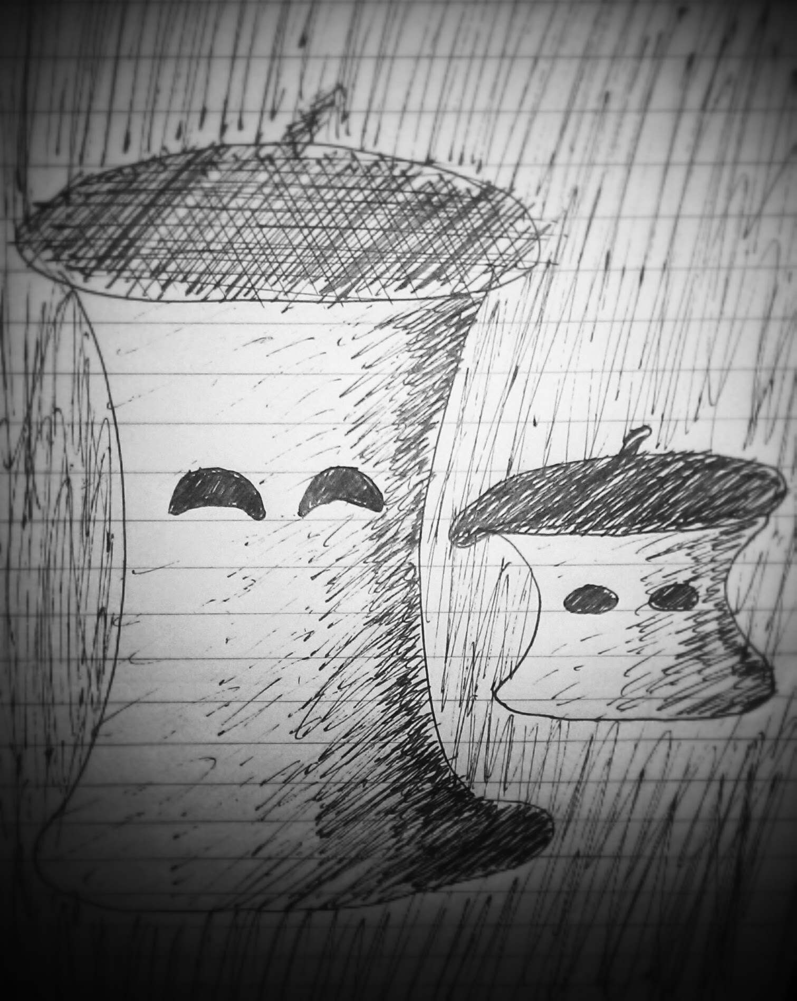

Formalities
Institute:
The Mærsk McKiney Møller Institute, University of Southern Denmark
Start Date:
1st of Oktober 2014

Submission Date:
1st of June 2015
This is a 40 ECTS points project:
- 10 points in the fall semester 2014,
- 30 points in the spring semester 2015.

Project supervisor:
Associate Professor, MMMI,
Poramate Manoonpong

Motivation
Two underlying motivating factors influence this project, creating artificial life and understanding deep learning algorithms. Experience with embodiment and the subsumption architecture is a learning choice opposed by painstakingly thought out complicated final state machines. Simplicity and evolution is key in this project which fits well with the subsumption ideas. As introduced by Rodney Brooks, embodiment seems to be an effective way of developing complex and robust biological behaviours iteratively from simple components. Deep learning is a popular new machine learning approach capable of achieving some of the most accurate and general classification results of contemporary techniques. What better way to learn about these kind of algorithms than to implement them on a robot, first using pre-trained knowledge/rules, but especially when it itself should learn and improve automatically from data it collects during its operation. The other aspect of artificial life is driven by the ever closer realization of intelligent robot entering the world in all of its facets, from industry to companionship. Trying to predict the final form of robots at the turn of this century would be naive, but exploration of the possibilities of robotics of our own present time could most certainly be beneficial and interesting none the less. The specific strand of research involving animal/human-like behaviours and means of communication is deemed relevant due to the fact that we inescapably are humans with behaviours to fit. There are surprisingly many dimensions to our own interaction with each other, all of which come natural to us, e.g. reinforcing speech with hand gestures or raising an eyebrow to influence the meaning of a certain statement. Utilizing these often pseudo-subconscious gestures have the potential to ease interaction with computers and robots significantly. An extreme extrapolation of this idea is to create artificial life with behaviours similar to our own in order to achieve both optimal communication, but not least a new species to interact with.

Objective
As an educational project, researching and implementing machine learning techniques and artificial life models are main objectives in themselves. These are however deeply integrated in the objective of developing a living mood lamp robot, that reacts intuitively to domestic sound events. Through this, obtain experience with theory an implementation of machine learning techniques and artificial life models. This robot can be arbitrarily complicated, so the project will be constrained to working with the most essential parts that make up such a robot. These parts are:

Robot Platform
Improve the Pepper robot lamp platform with e.g. the following features:
  - body with 5 DOF constrained movement(large spring, tendons and servos)
  - Powerful 220V RGB LED bulb for lighting and reinforcement of emotion
  - Expressive eyes, that can covey emotion
  - Directional sound input
  - Ambient light sensor

Sound Event clustering
Use machine learning to cluster unique sound events from continuous sound, e.g.:
- Sudden or constant noises (especially whether new to the robot or not)
- speech(including tone of voice) directed at the robot vs. conversation
- music(rhythm).

Then, with these clusters, define appropriate reactions, and severity, which fit the robots identity as a small living mood lamp, e.g. looking towards a new sound or speech source, ignoring irrelevant or well known sounds, changing mood or following rythm of music. The data would come in form of sounds in a room and labeled live, right or wrong, by the human which observe whether the robots reaction is appropriate.

Artificial Life
Incorporate relevant artificial-life aspects to reinforce the goal, e.g. mood, attention and habituation, curiosity, drive(e.g . Social vs. Entertainment, vs. rest) and motivation, based on research from robots like Kismet or Keepon.

Preliminary work and project delimitation
This project expands upon the Pepper robot platform, developed as a project in the course AI4 of the 2014 autumn semester. Pepper consists of a cylindrically shaped body made of white cloth over a simple rigid skeleton with 1DOF swivel movement and a powerful RGB LED for lighting. It has directional microphones a input. It is capable recognizing difference between positive and negative tone of voice using machine learning and reacts accordingly by changing its own mood, expressed by colour and eye shape.

The focus will be on clustering different sound events and estimating their relative novelty to the robot, with each class sparking an appropriate reaction. A part of the project is also to figure out what behaviours are essential with the product goal in mind. Not all the desired features can be implemented fully in one project, but their mention reinforce the prospect of the robots as a whole, justifying working on the essential features.

The design of the robot platform is pretty far ahead and will be simple, but fitting to the robots identity as a living mood lamp.

Project Requirements

Documentation
Documentation will be in the form of a comprehensive technical and scientific thesis report, describing both relevant theory, technical design choices and experimental results.

Product Evaluation
Scientific experiments will be conducted in order to evaluate the performance of each individual behavioural feature. Additionally, a survey evaluating the overall performance of the robot will be conducted, based on a small set users', specifically how they react to the robot in its target environment.

Project Plan
Week 40-43: Develop design ideas
Week 44-48: Research deep learning and artificial life theory; work on preliminary project.
Week 49-52: Research theory and improve robot platform; finish preliminary project
Week 1-4: Implement Clustering algorithm, implement robot behaviours(movement, mood change)
Week 5-9: Improve Clustering, implement artificial life features.
Week 10-13: Combine behaviours with input data analysis
Week 14: Tie together loose ends and optimize overall robot performance
Week 15-16: Experiments, individual technical features
Week 17: Experiment, overall robot performance
Week 18-21: Document development process and experiments
Week 22: Documentation finished, proof read.
01/06, Week 23: Hand in Thesis

Learning Goals:
As an educational project, several general learning goals have been defined. The following is taken from the official SDU course description:

Knowledge
The student
- is able to account for relevant engineering skills based on the highest level of international research within the subject area of the programme
- has a good understanding of - and be able to reflect on - relevant knowledge within the subject area of the programme
- is able to identify relevant scientific problems within the subject area of the programme

Skills
The student
- is able to assess, select and apply scientific methods, tools and competencies within the subject area of the course
- is able to present novel analysis and problem-solving models
- is able to explain and discuss relevant professional and scientific problems
- is able to communicate in writing in a clear and understandable manner

Competence
The Student
- is able to manage work and development situations that are complex and unforeseen and require new solution models
- is able to independently initiate and carry out discipline-specific and cross disciplinary cooperation and to assume professional responsibility
- is able to independently take responsibility for his/her own professional development and specialization
- is able to disseminate research-based knowledge

Student Information
Title and Name:
BSc. Lasse Simmelsgaard Børresen

Contact Information:
Phone: 0045 41356060
Email: laboe10@student.sdu.dk
Address: Absalonsgade 19 St. 3, 5000 Odense C, Denmark



